ANSIBLE – TASK – 01
===========================================================================

- Watch ansible-01 video and write down notes.
- Setup one master and two worker nodes in ansible.

- Opened EC2 → Launch instance
- Selected Ubuntu AMI
- Set Number of instances = 3
- creating:
  - 1 Ansible Controller
  - 2 Ansible Worker nodes

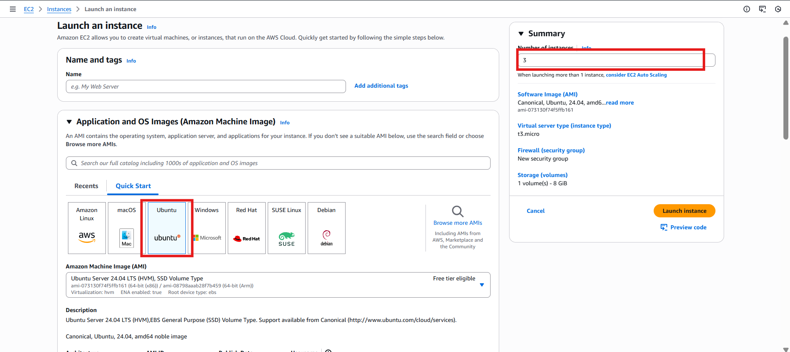

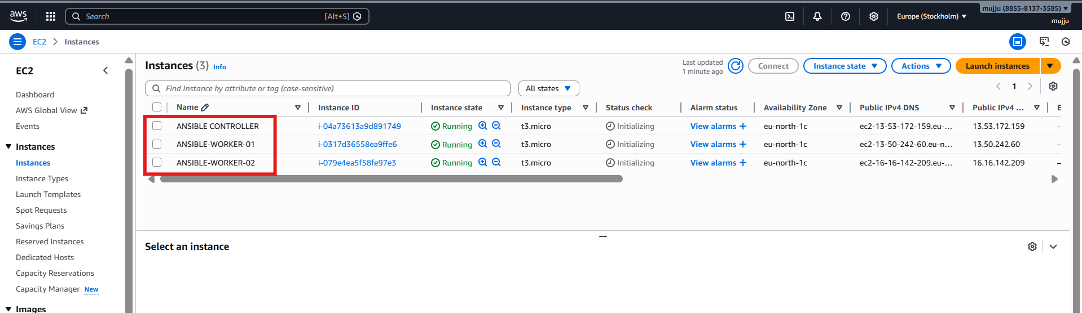
- Connected to ansible master by using ssh
- checked
- python3 --version

- Ansible depends on Python

- Ubuntu 24.04 comes with Python 3.12
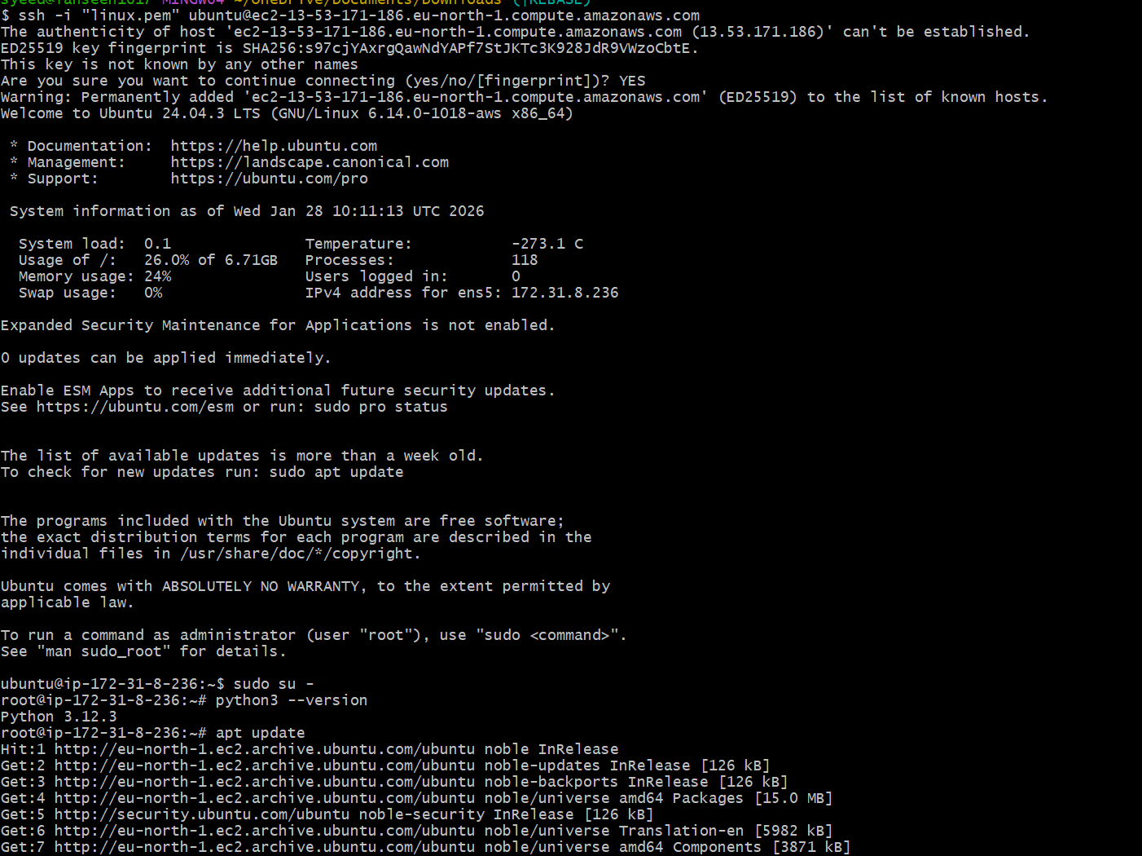
- apt install ansible -y
- Installs:
- ansible-core
- python libraries
- Ansible is now available system-wide
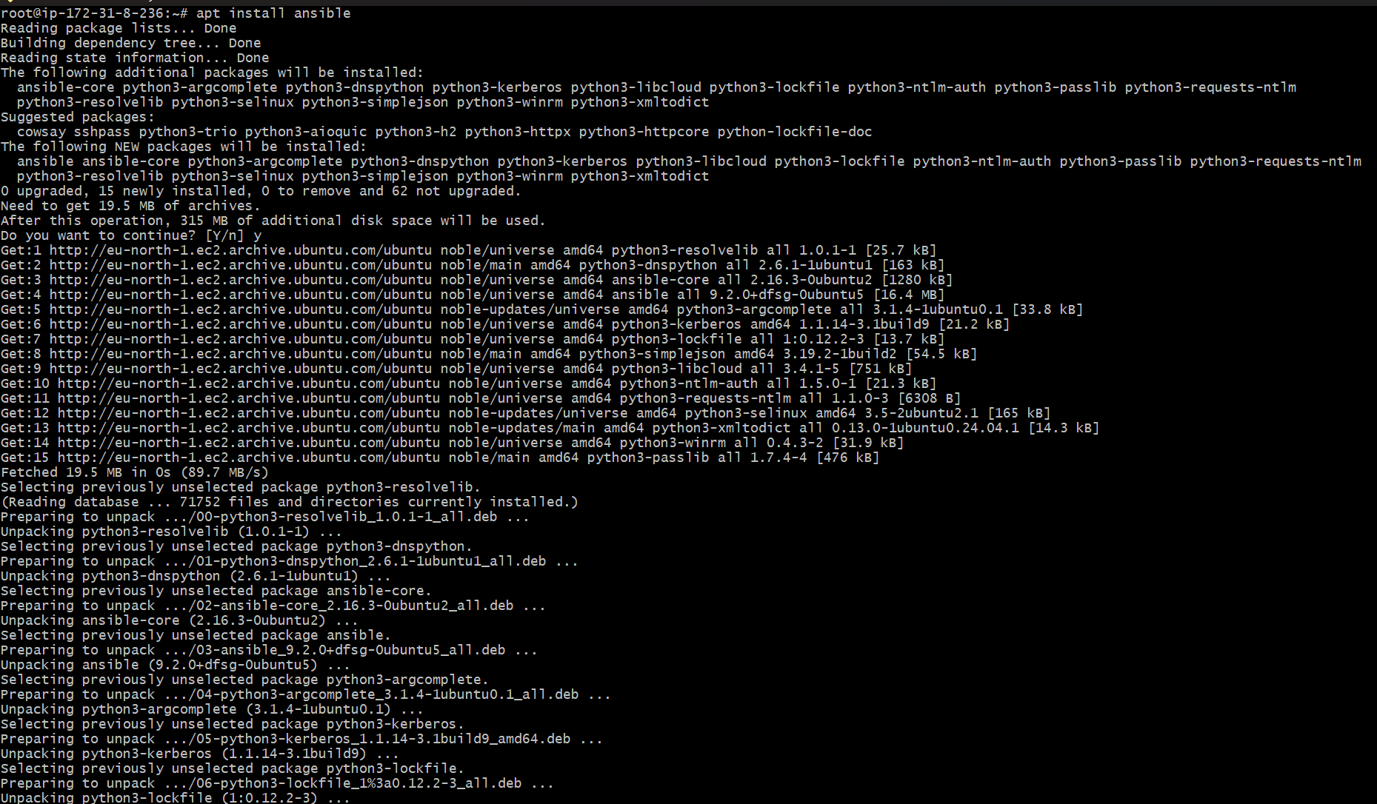
- ansible --version
- Output confirms

- Ansible version installed

- Python path

- Plugin locations

- There was no config file
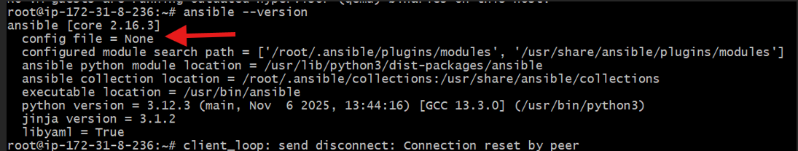

- Created a directory
- mkdir -p /etc/ansible
- created a file
- touch /etc/ansible/ansible.cfg

- vi /etc/ansible/ansible.cfg
- Config added

[defaults]
remote_user = root
host_key_checking = False
forks = 10


- ansible --version
- Important check

- config file = /etc/ansible/ansible.cfg

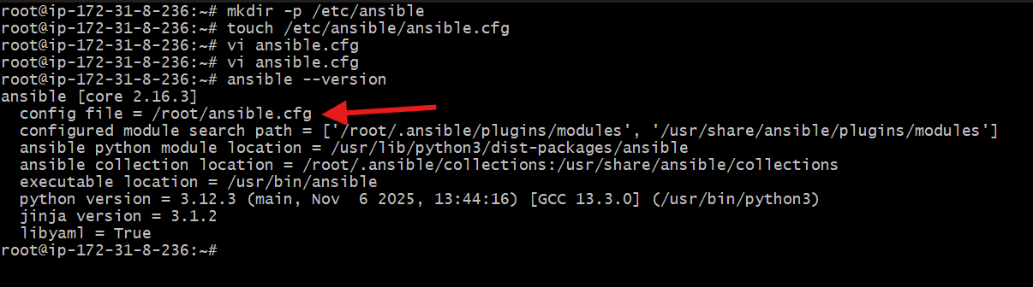
- Create Inventory File (hosts)
- cd /etc/ansible
- vi hosts


- Edited /etc/ansible/hosts
- Added private IPs of worker nodes
- Created groups: all, worker-01, worker-02
- Purpose: Tell Ansible which machines to manage


Generate SSH Key on Controller
- ssh-keygen
- Created key pair:
- cat /root/.ssh/id_ed25519.pub
- Copied public key
- This key will be pasted on worker nodes
- Purpose: Passwordless SSH from controller to workers
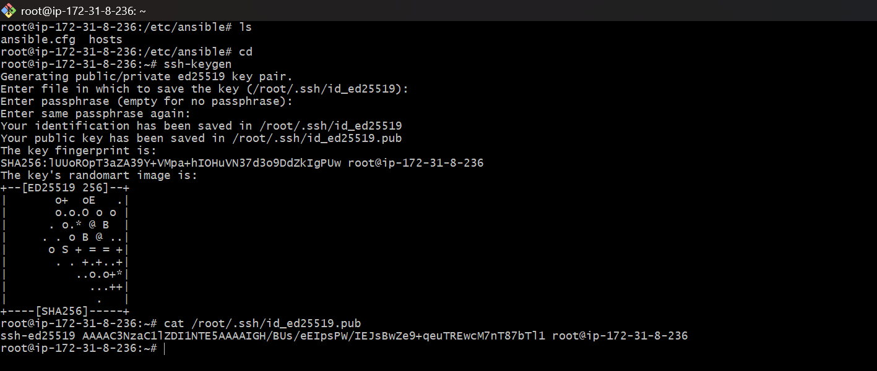

Add Key to authorized_keys (Worker-01)
- cd ~/.ssh
- vi authorized_keys
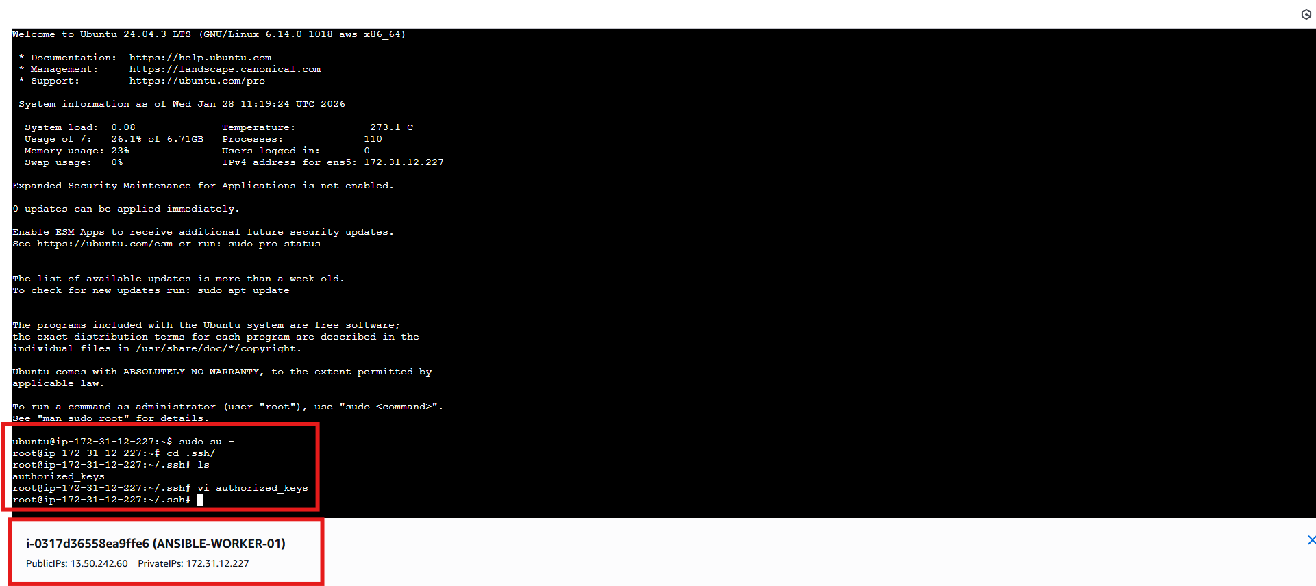
- Pasted controller’s public key
- Saved file
- Purpose: Allow controller to SSH without password

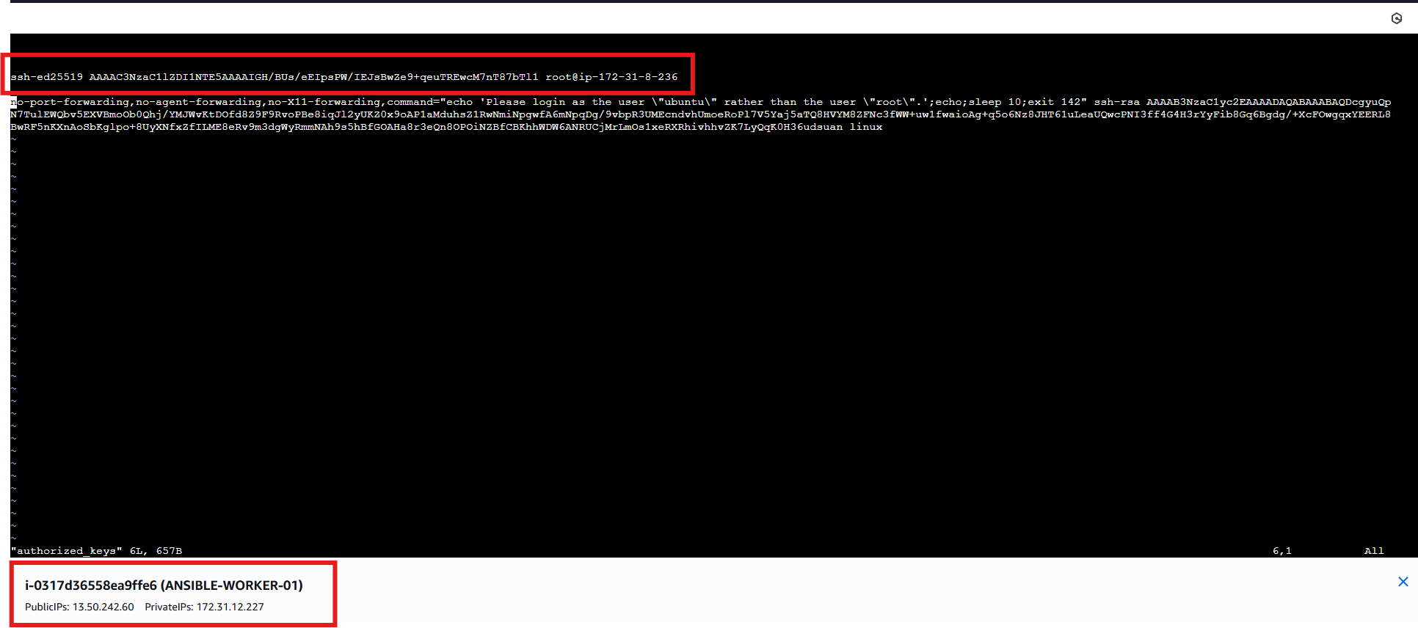

Repeat Same on Worker-02

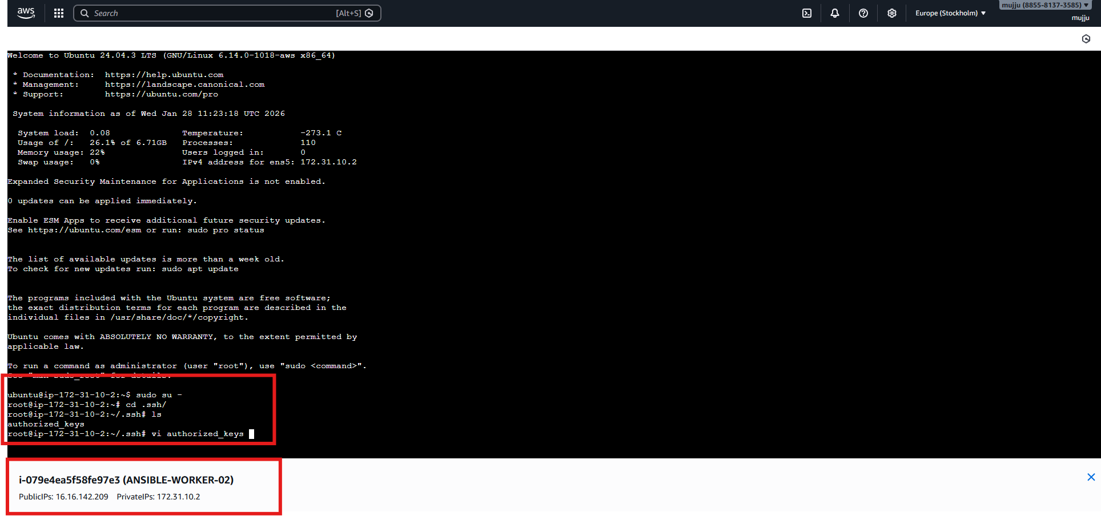

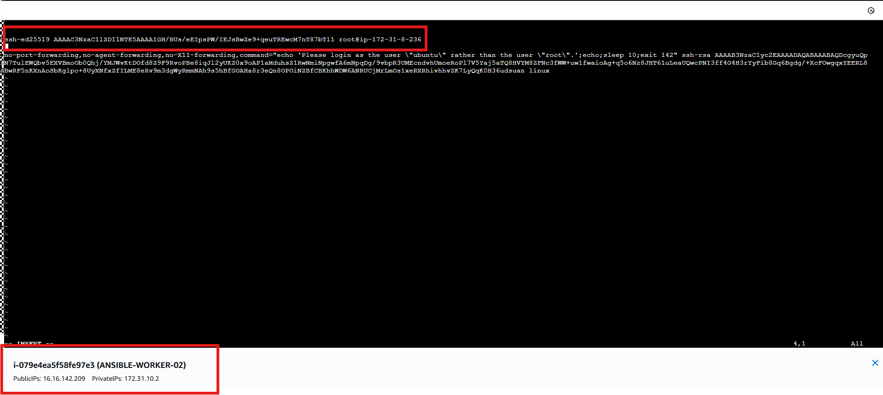
Test Ansible Connectivity
- ansible all -m ping
- Result
- SUCCESS
- "ping": "pong"
- Means:
- SSH working
- Ansible working
- Inventory correct

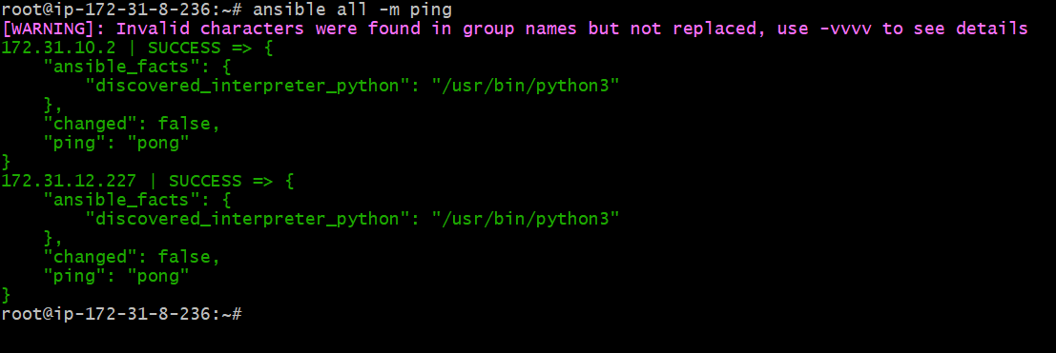

- Execute the adhoc command shared in #dvps-cloud-documents-12 Channel.

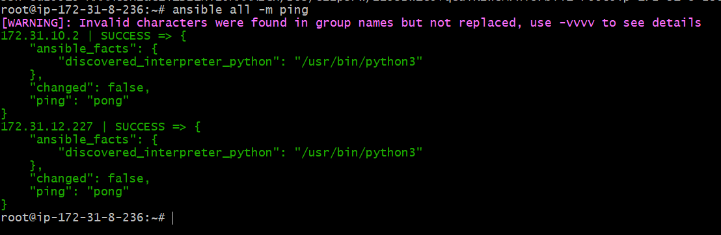

Command
ansible worker-01 -m ping

Use
- Tests connectivity between Ansible controller and worker-01
- Confirms:
  - SSH works
  - Python is available
  - Ansible can execute modules
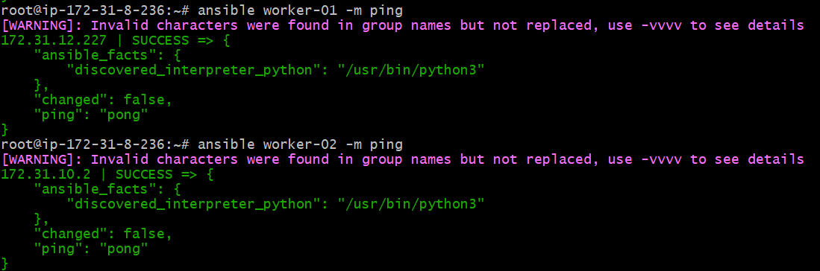
- Command
- ansible all -m setup
Use
- Collects system facts from all hosts
- Used internally by Ansible for automation logic
Output
- Large JSON output containing:
  - OS version
  - IP address
  - CPU
  - Memory
  - Disk
  - Network interfaces



Command
ansible all -a uptime
Use
- Runs Linux uptime command on all hosts
- Shows how long servers are running and load

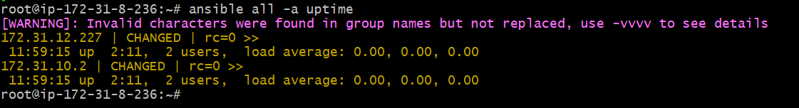

Command
ansible all -m ping -vvv
Use
- Same as ping
- -vvv shows debug-level details
- Useful for troubleshooting SSH or inventory issues

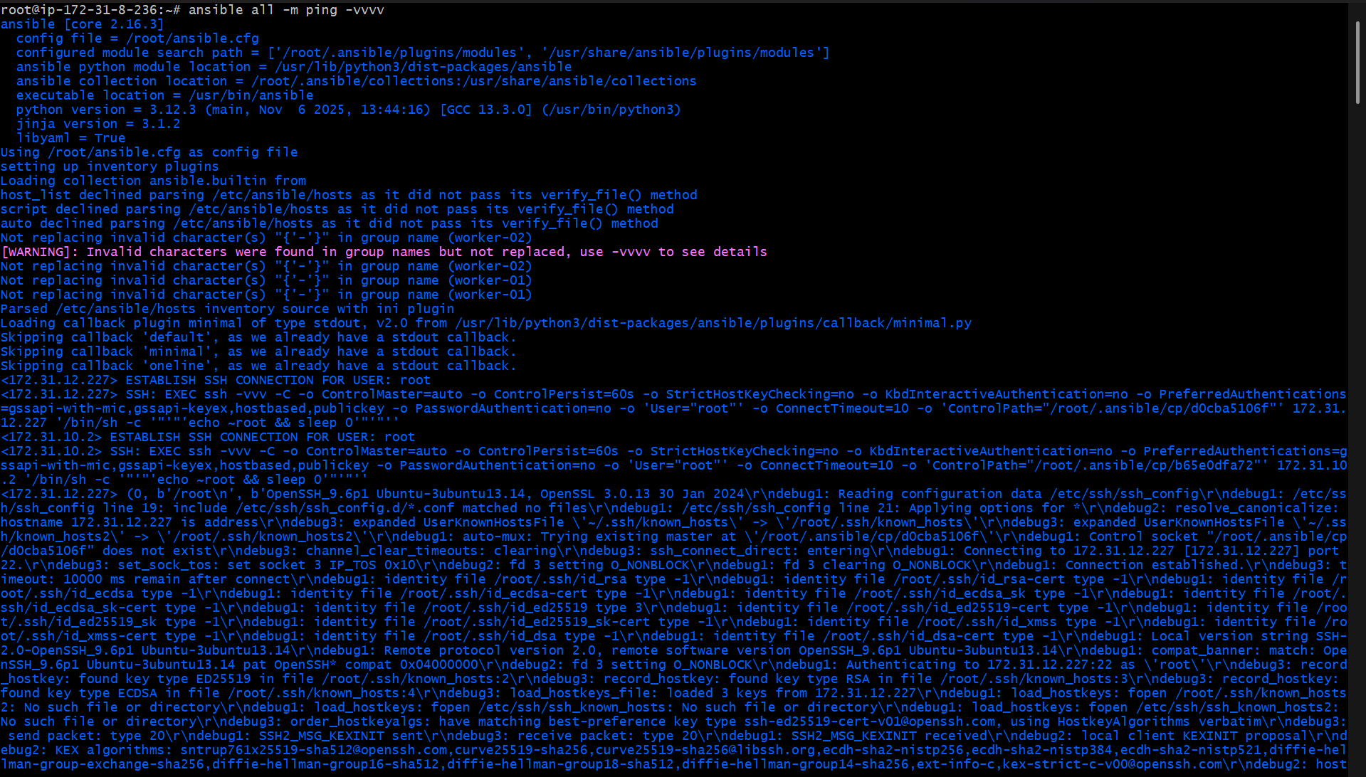

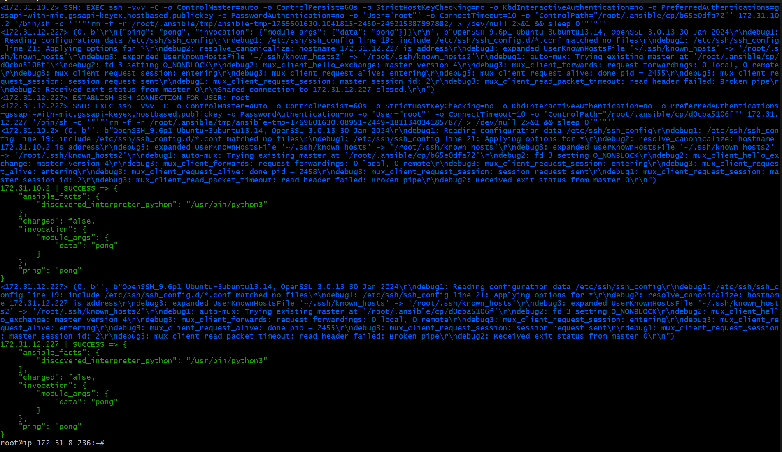

Command
ansible all -m shell -a "free -m"
Use
- Checks memory usage on all servers

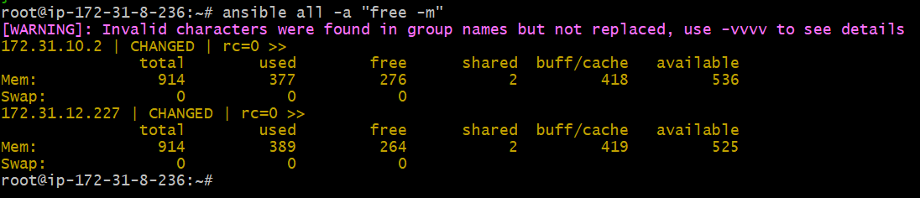

Command
ansible all -m shell -a "mkdir ansible.log"
Use
- Creates directory ansible.log on all hosts

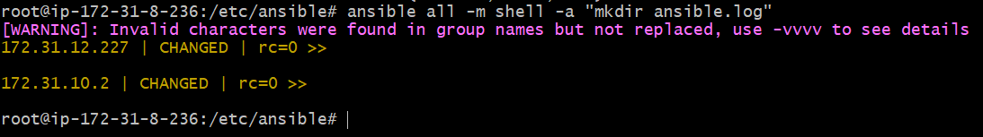

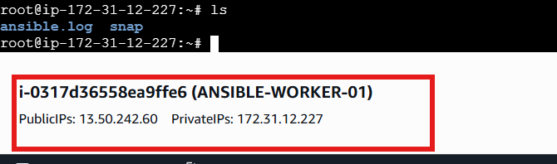

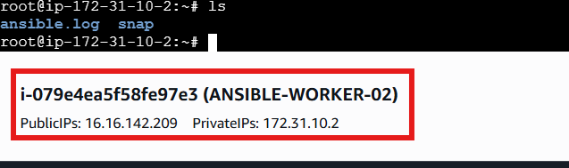

Command
ansible all -m apt -a "update_cache=yes cache_valid_time=0" -b
Use
- Updates package list on all Ubuntu nodes
- -b → run as root (sudo)
Command
ansible all -m apt -a "name=apache2 state=present" -b
Use
- Installs Apache web server on all nodes

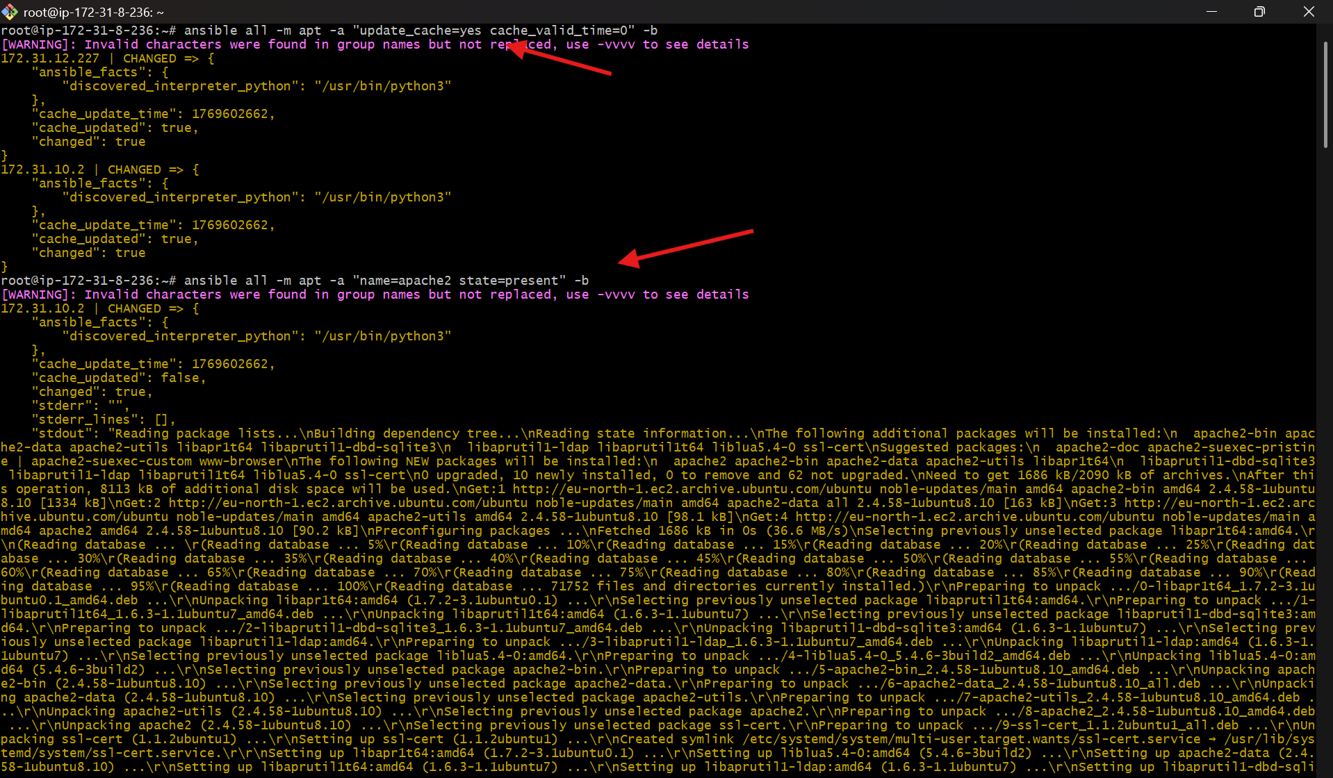

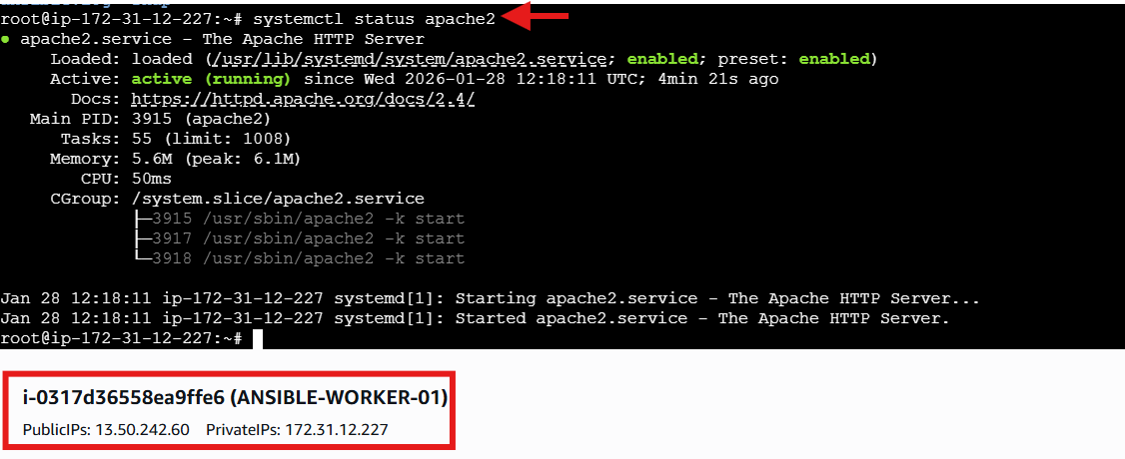

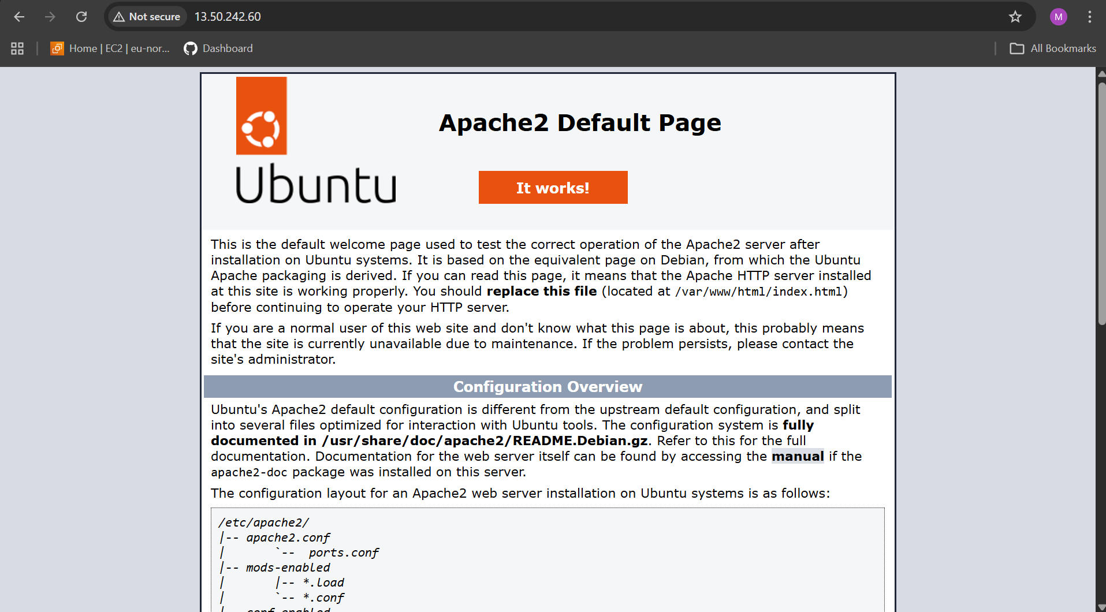

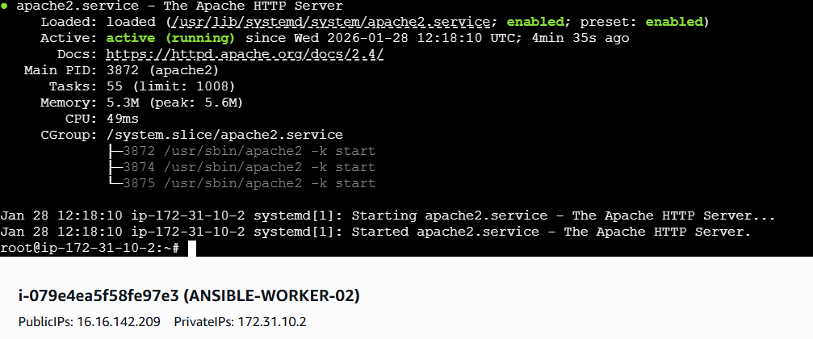

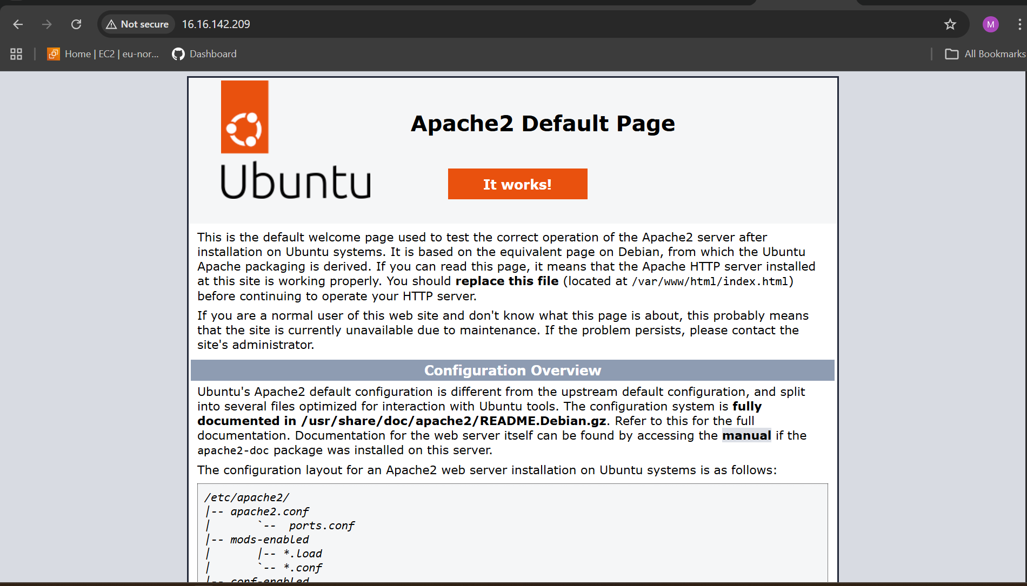

Command
ansible all -m service -a "name=apache2 state=stopped enabled=yes" -b
Use
- Stops Apache
- Ensures service starts on boot

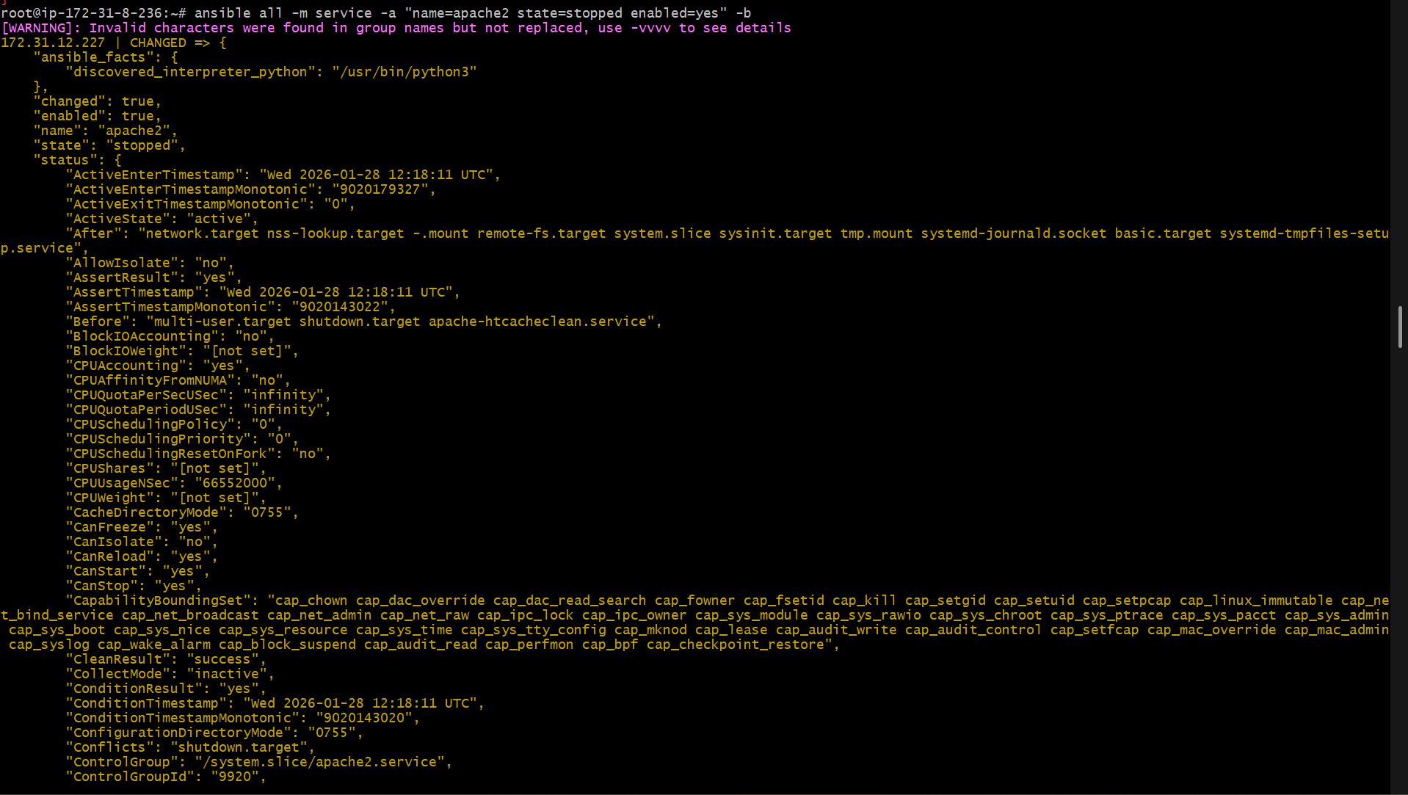

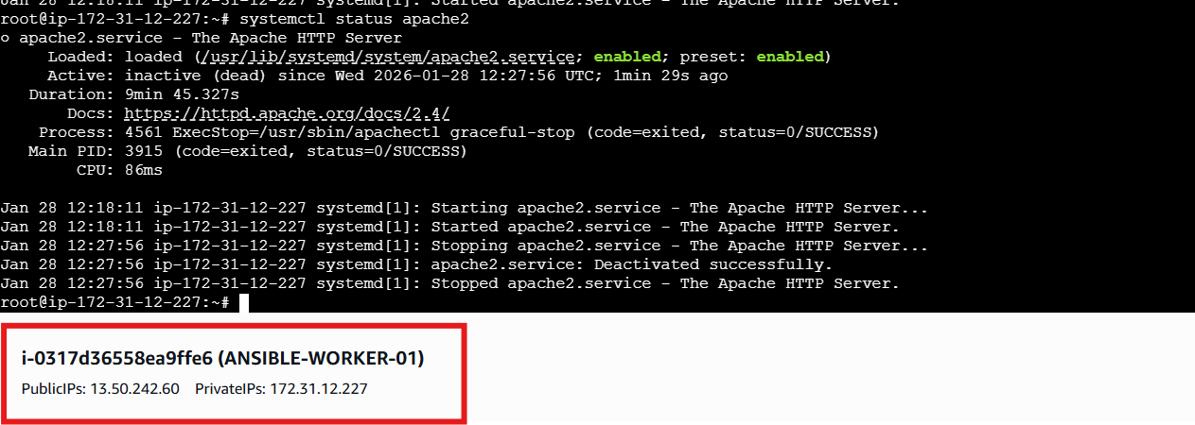

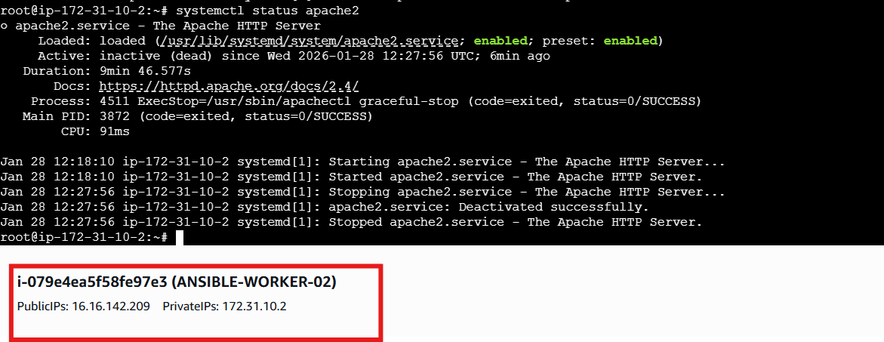

Command
ansible all -m user -a "name=weblogic state=present"
Use
- Creates user weblogic
- Creates home directory automatically
Command
ansible all -m shell -a "id weblogic"
Use
- Confirms user exists
- Shows UID, GID, groups

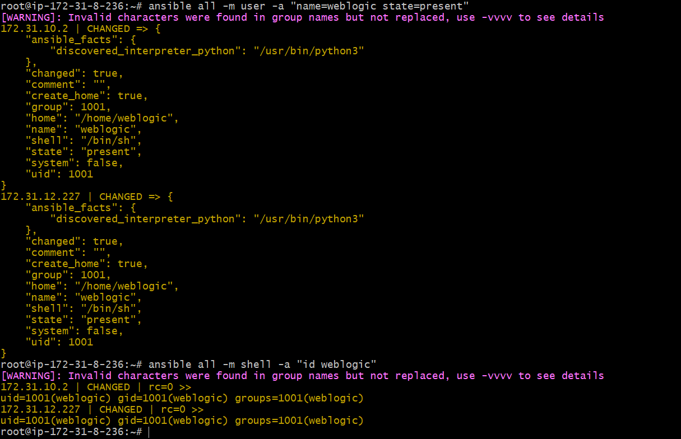

Command
ansible all -m file -a "path=/root/demo state=touch mode=0755"
Use
- Creates file /root/demo
- Sets permission to 0755

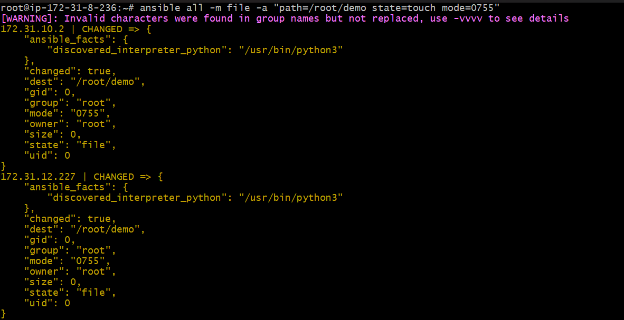

Command
ansible all -a "ls -l /root/demo" -b
What this command does
- ansible all → run on all managed hosts
- -a "ls -l /root/demo" → executes Linux ls -l command
- -b → become root (sudo)

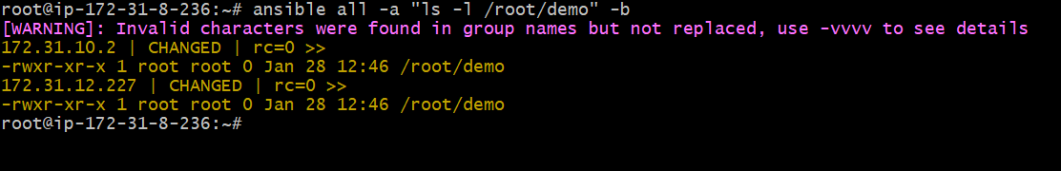
Command
ansible all -m group -a "name=test state=present" -b -K
What this command does
- -m group → uses group module
- name=test → group name is test
- state=present → ensure group exists
- -b → run as root
- -K → ask for sudo (become) password

